|  |  |
| --- | --- |
| Inclusive Growth On the Road.  Health & Ageing | |
|  | |
|  | 5-6 December 2019  Inclusive Growth On the Road_  Hop on to improve Health & Ageing services.  Starting and end point at HILTON ANTWERP OLD TOWN  GROENPLAATS 32,  Antwerp, Belgium. |
|  | |



Outlines

Did you know that Cooperation programmes will be allocating during this programming period around 1.4 billion euros in social policy? Yes, Interreg, IPA and Neighbourhood programmes are also financing projects on employment, labour mobility, education and social inclusion, where health and ageing are tackled.

In 2017, Interact launched the Inclusive Growth thematic network (later I.G. network) in order to build capacity among the EU cooperation programmes. Its primary goal is to make available relevant data to better understand the topic, to share practices and to capitalise results. In this framework, Interact jointly with ***Interreg 2 Seas, Interreg Grande Région, Interreg France-Wallonie-Vlaanderen, Interreg Vlaanderen-Nederland,*** is organising this meeting***.*** The idea behind this concept is to support programmes working in the same area and under the same themes to reinforce the impact in the territory. However, this method could be of good example to other areas and therefore exported for next Inclusive Growth meetings.

Last year’s meeting was focused on Inclusive Growth from a general angle. This year, there are two novelties. On one side, it will be devoted specifically to “**Health and Ageing”**. On the other, it will be based on **field visits**, as it is the best way to learn and share experiences.

So be ready to hop on the bus and visit 3 projects in the area on health and ageing!

For more information on the added value of EU Cooperation on this topic check on the this [report](http://www.interact-eu.net/library?title=&field_fields_of_expertise_tid=All&field_networks_tid=82#2672-report-health-and-ageing-cooperation-programmes).

Objectives

1. **To learn more in site about the projects and programmes financing Health and ageing in the area.**
   * Field visits on Health awareness raising, R&D and ageing Innovative solutions. These are organised by Interreg 2 Seas, Interreg Vlaanderen-Nederland, Interreg France-Wallonie-Vlaanderen, Interreg Grande Région and Interact.
2. **To discuss between projects, programmes practitioners on how overlaps can turn into complementarities.**

* Different EU Cooperation programmes, H2020, Health, ESF programmes will share their experiences on how Health and Ageing projects are improving EU social policy in the current period

1. **To show the added value of Cooperation programmes in the priorities of health and ageing.**

.

|  |  |
| --- | --- |
| Day one  11.30 – 12.00  12.00 _ 13.00  13.00 – 16.00  (Bus trip back to Antwerp included)  16.00 – 16.45  16.45 – 18.00  18.30  Day two  09.30 – 11.00  11.00 – 11.15  11.15 – 12.45  12.45-13.00  13.00-14.00  14.30 | Thursday 5 of December 2019.  Focus on Ageing.  **Registration**  **Welcome lunch**  Hop on the bus for a ride to better Ageing  *How are the 4 programmes tackling Ageing?*  *Interreg 2 Seas, Interreg Grande Région, Interreg France-Wallonie-Vlaanderen, Interreg Vlaanderen-Nederland. By Wannes Haemers. Julie Champagne, Maëlle Berthelemy and Sara Peeters.*  Bus Stop at Ten Kerselaere_Emmaüs (Heist-op-den-Berg) to visit CASCADE and TICC projects (Interreg 2 Seas). Presentation done by Sabine Van Houdt     * Aim: The field visit leads us to a care concept with emphasis on housing, living & care dimensions. Elderly care being holistic   Health and Ageing in post 2020.  Moderation: Mercedes Acitores.   * Valeria Cenacchi from DG Regio * Katarzyna KIELAR from DG Sante * Beatrice Lucaroni from DG Research (tbc)   Debate   * Aim: This session intends to find complementarities between the 3 different policy areas that are financing projects in the scope of Health and Ageing to improve its impact in the next period. Debate will be encouraged.   Innovative solutions in Ageing projects.  Moderation and conclusion _Philippe Seidel. AGE Platform.   * Anne- Laure Maclot and Chritophe Muller. SENIOR ACTIV project. Interreg Grande Région. Enhancing Competence and skills. * Elisabeth MASSIN. A-P/RESEAU-SERVICE project. Interreg France-Wallonie-Vlaanderen. Enhancing Competence and skills. * Erwin Roggen. Herinneringen project. Interreg Vlaanderen-Nederland. Combating specific diseases. * Nathalie Bekx Road 67. ESF project. Active Ageing     Debate   * Aim: From overlaps to synergies. Different programmes will share their experiences in Ageing from different angles with the aim of finding synergies and a better impact in the area. Debate will be encouraged.   Networking dinner included. End of Day 1.  Friday, 6 of December 2019.  Focus on Health services  Hop on the bus for a ride to better health services.  *How are the 4 programmes tackling Health services?*  *Interreg 2 Seas, Interreg Grande Région, Interreg France-Wallonie-Vlaanderen, Interreg Vlaanderen-Nederland.*  *By Vincent Hagnere, Yasmine Clement, Maëlle Berthelemy and Sara Peeters.*  Bus Stop at GKC (Wilrijk) to visit ZORO (*Interreg Vlaanderen-Nederland)*. Presentation done by Jolien Bernaerts  **Coffee Break**  Innovative solutions in Health projects.  *Moderation ESF.Alexander Elu*   * *Valentina Polylas. EUREGHA. Health care in H2020* * *Ruben Vanbosseghem. DWELL project. Interreg 2 Seas.* *eHealth.* * *Thomas Vangijzegem. NanoCardio project. Interreg France-Wallonie-Vlaanderen. R&D.*   *Debate*   * From overlaps to synergies. Different programmes will share their experiences in improving Health services from different angles *with the* aim of finding synergies and a better impact in the area.Debate will be encouraged.   **Conclusions.**  **Lunch**  Hop off the bus. End of the event |

Practicalities

Venues

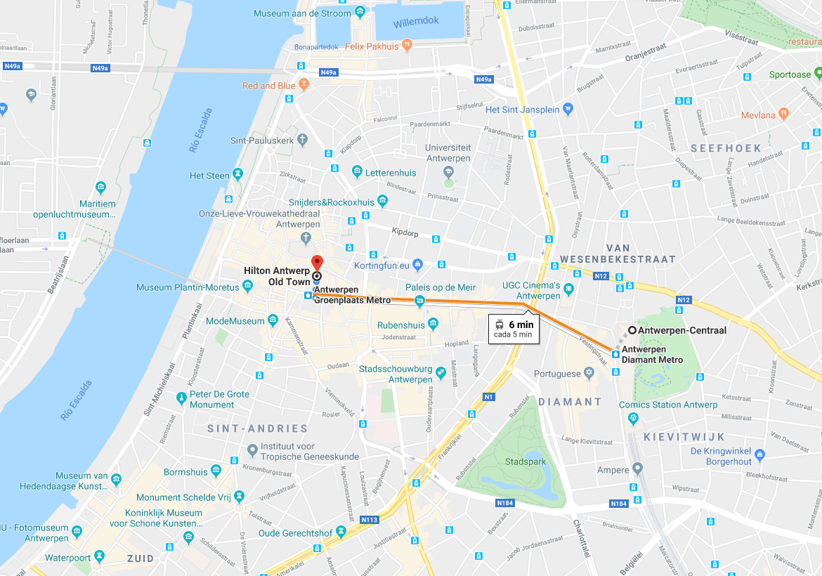Since the event will be moving… The first and last meeting point will be at the HILTON ANTWERP OLD TOWN. GROENPLAATS 32, ANTWERP, ANTWERP, 2000, BELGIUM

Travel

To get to Antwerp the best option would be to go directly to Brussels Zaventem and get a train to Antwerp from the airport directly. The train trip takes around 30 minutes.

The Train Station is in a 6 minutes distance (by tram) from the venue.

Other information

Report on Health and Ageing in EU Cooperation Programmes. [Here](http://www.interact-eu.net/library?title=&field_fields_of_expertise_tid=All&field_networks_tid=82#2672-report-health-and-ageing-cooperation-programmes)